Coyote Camp is a time when Students learn what it is like to be a Coble Coyote!

Students will go on a tour of the school, learn the Coyote traditions, attend a pep rally, learn how to use their lockers, and meet new friends before school starts.

Lunch will be provided.

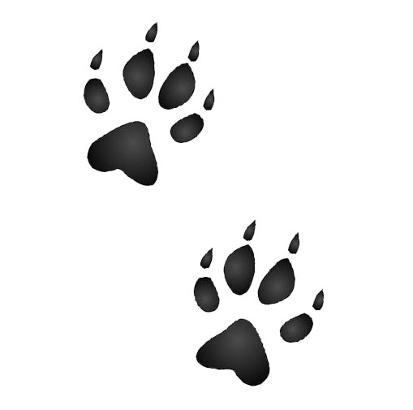

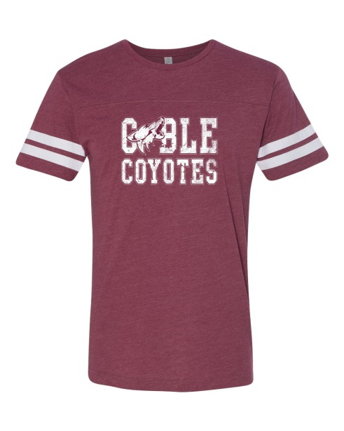

Coble Spirit shirts will be available for purchase the day of camp.
$15.00

Now You’re A...
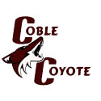

Camp Date
Tuesday August 1, 2017
Schedule of Events
Student Check-In Cafeteria @ 9:00
Drop off and Pick up will be in the back between the gym and Cafe
Coyote Camp 9:30-12:00
Parent Meeting 11:00-12:00
Library
Student Lunch 11:30-12:00
Pizza and Drink

REGISTRATION FORM
COYOTE CAMP 2017
DUE July 26, 2017

STUDENTS NAME:___________________________
PARENT NAME:_____________________________
PHONE NUMBER: ___________________________
STUDENT ALLERGIES, MEDICATION, MEDICAL CONDITIONS: ______________________________
_________________________________________
EMERGENCY CONTACT NAME/NUMBER:
_________________________________________
_________________________________________
I will ___ Will not____ be attending the Parent Meeting at 11:00
PLEASE MAIL OR BRING THIS FORM AND $5.00 REGISTRATION FEE TO:
JAMES COBLE MIDDLE SCHOOL
ATTN: COYOTE CAMP
1200 BALLWEG ROAD
Arlington, TX 76002

For any questions contact
Laura Myers
lauramyers@misdmail.org

